Sometimes, it may happen that while running the tests as Run as🡪 Maven test, the compiler was not found (below error) may occurred. In order to resolve it, follow the following solution.

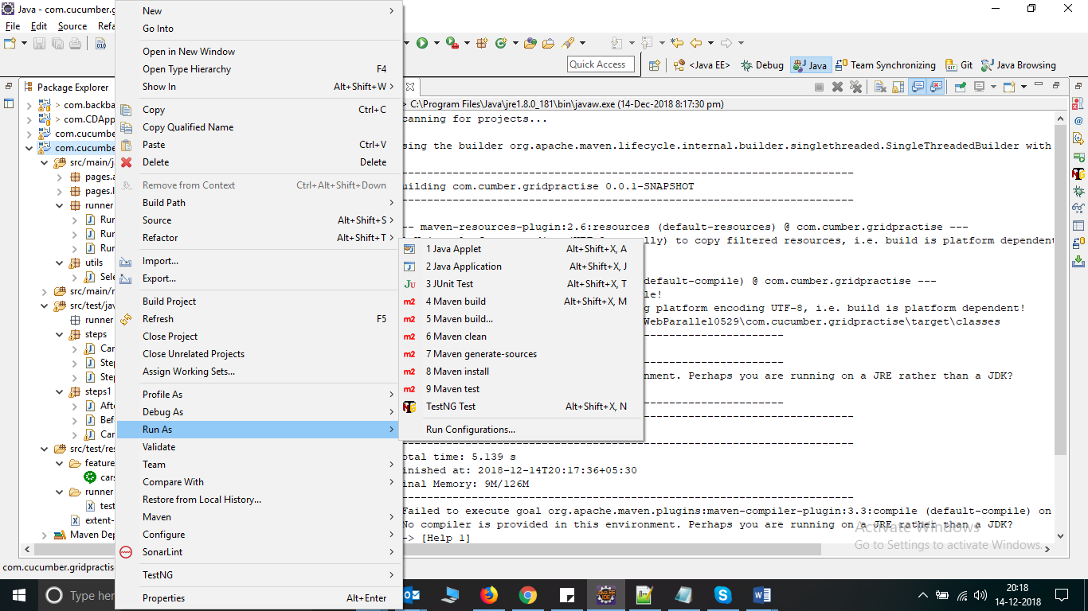

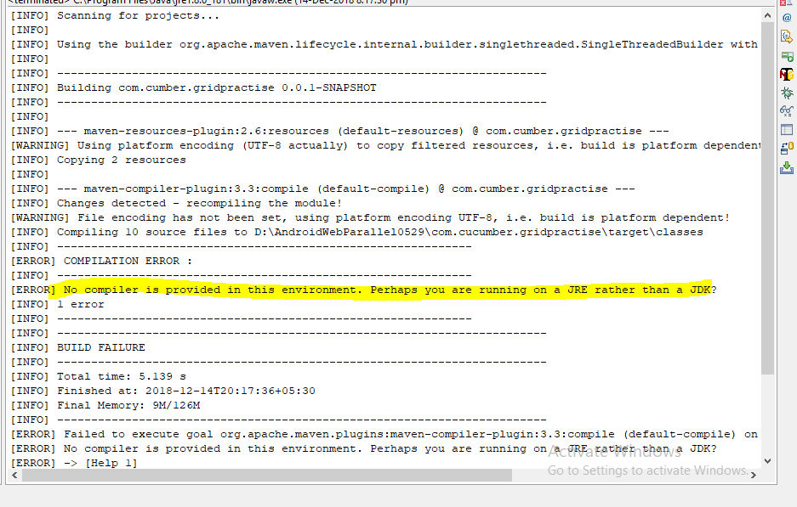

Solution: Right click project, go to Configure build path🡪 Libraries 🡪 Select JRE system library

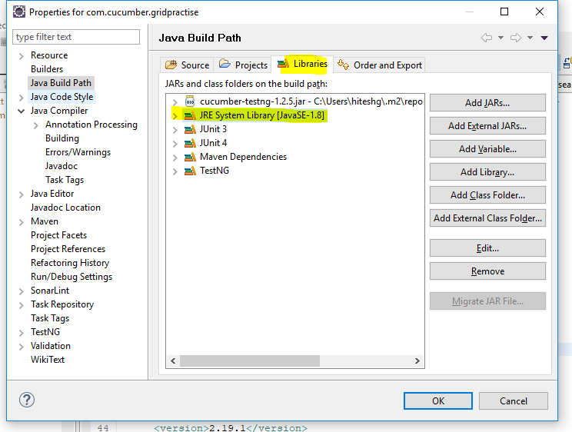

Click on edit button and then select “Alternate JRE” and then click on “Installed JRE” and make sure the following settings

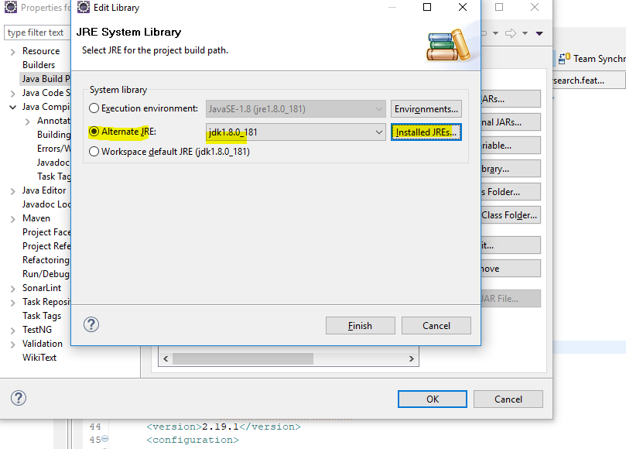

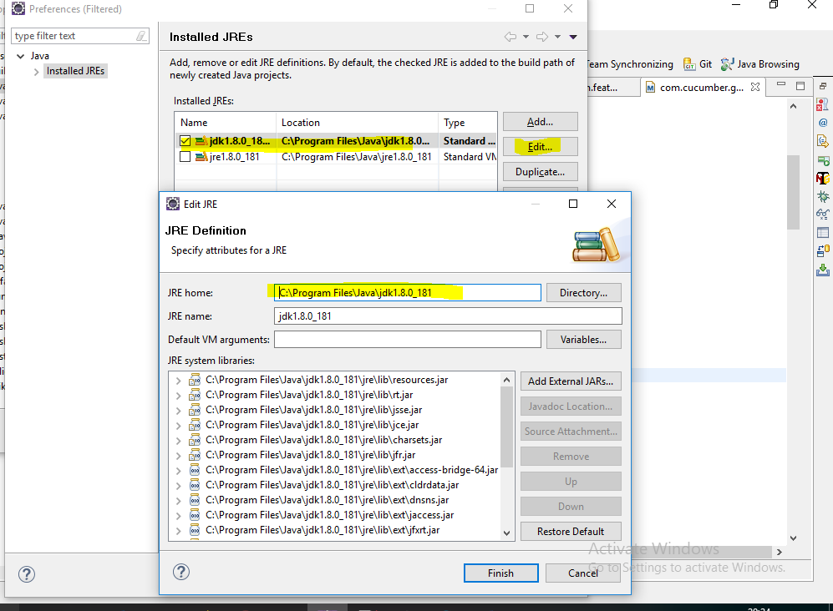

After doing the above changes, errors in my project was removed.

